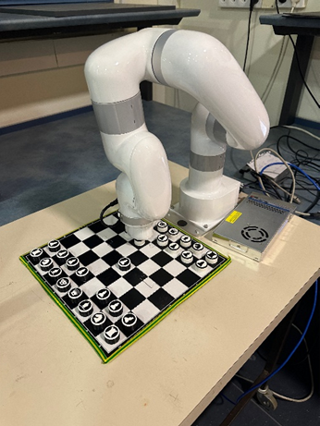RoboChess: Chess Playing Robotic Arm

**Introduction**  
The recent surge in popularity of both chess and advancements in AI and robotics technology has led to the innovative integration of these fields in our project. Our goal was to create a fully functional chess game against a robotic arm, providing an interactive experience without the need for computer interaction.  
  
**Goals**  
The project was built with several objectives in mind, including the accurate detection of a physical chessboard and pieces using a stereo depth camera, recognition of player actions, and enabling the robotic arm to pick, place, and move chess pieces with precision. A significant challenge was ensuring the robot could correctly solve incorrect moves and adjust its actions accordingly.  
  
**Approach**  
To achieve these goals, we employed several techniques:  
- Implementing a circle Hough transform to accurately locate and track pieces.  
- Incorporating Stockfish, a powerful chess engine, to analyze gameplay and ensure legal moves.  
- Controlling the robotic arm's motion using inverse kinematics to calculate precise joint angles.  
  
**Results & Conclusion**The system successfully detects changes in the game state and executes moves with the robotic arm, incorporating varying search radii and pressure sensing for grip confirmation. The project culminates in an interactive experience that allows for a seamless chess game against a robotic opponent, complete with a user interface to visualize progress.  
  
The project demonstrates the effective combination of image processing, computer vision, and robotic control systems to create an engaging and modern approach to playing chess. The versatility and accuracy of the arm in detecting and responding to gameplay highlight the potential of robotics in entertainment and education.